

**A Project Report On**

**Course Code -** MCA617A

**Course Name -** Mini Project on Open Source

**Submitted By:**

**Anitha Susan Alex (19MCA003)**

**(Academic Year - 2020-2021)**

**IN PARTIAL FULFILLMENT OF**

**Course Code and Name:** MCA617A - Mini Project on Open Source

**Name of Program: MCA Management**

**As prescribed by MIT-World Peace University**

**MIT-World Peace University School of Management PG, Pune**

# CERTIFICATE

This is to certify that Ms Anitha Susan Alex of MIT-WPU School of Management (PG) have successfully completed the desk research work titled Billing Software in partial fulfilment of requirement for **Course** MCA617A **Code and Name** Mini Project on Open Sourceasprescribed by the **MIT-World Peace University**.

This Report is the record of authentic work carried out during the academic year 2020-21.

|  |  |  |
| --- | --- | --- |
| **Dr. Harshali Patil** |  | **Prof. Sridhar G.** |
|  |  | Prof. Dr. T. J. Vidyasagar  Head of School  MITWPU SoM(PG) |

# DECLARATION

I, Ms. Anitha Susan Alex hereby declare that this Project Report is the record of authentic work carried out by us during the academic year 2020-21 and has not been submitted to any other University or Institute towards the award of any degree.

|  |  |  |
| --- | --- | --- |
| **19MCA003** | **Anitha Susan Alex** |  |

# PROJECT DESCRIPTION

**Title –** Billing Software

**Team Involved:**

**Member 1 -** Anitha Susan Alex (19MCA003)

# INDEX

|  |  |  |
| --- | --- | --- |
| **SR.NO.** | **TITLE** | **PAGE NO.** |
| 1 | Overview | 6 |
| 2 | Objectives of the System | 7 |
| 3 | Development Environment | 8 |
| 4 | Screen Shots | 9 - 42 |
| 5 | Code Snippet | 43 – 51 |
| 6 | References | 51 |

## 1. Overview of the Project:

A billing software is designed to handle time, billing tracking and invoicing customers for services and products.

Billing software is an integral part of an accounting and finance software. However, the billing system software can range from the simplest and most basic to the more advanced billing software for PC with sophisticated features.

In this project, the registrar can generate bills by entering the order details and customer details, total price including tax is calculated and the bill is generated; this bill can be saved as a text file if needed and also searched (if saved) using bill number.

The modules in this project are :-

* **Calculate Product Price** - Calculates total price of the products bought by the customer.
* **Calculate Tax** - Calculates the taxes for the products.
* **Generate Bills** – Generate a bill including the total price, bill details and customer details.
* **Save Bill** – An option to save the bill in the system in the form of text file.
* **Search Bill Records** – An option to search a particular bill using Bill no. and display it.

## 2. Objectives of the System:

### Existing System:

* The registrar or user has to manually create a bill, i.e, there’s too many manual working involved in the existing system.
* It is much more time-consuming and hectic.
* There can be errors in the bill, i.e., no accuracy or precision which can raise complaints or customer loss.

### Need for Computerization:

The objective of this software is to eliminate manual data entry, reduce time, and eliminate errors to ensure accounting figures are accurate; such that it keeps business processes systematic, easy, and timely.

## 3. Development Environment:

### Software:

* Operating System: Windows or Linux
* Technology: Python
* IDE: Spyder 3.36

## 4. Screen Shots (Input Screens and Report Screens):

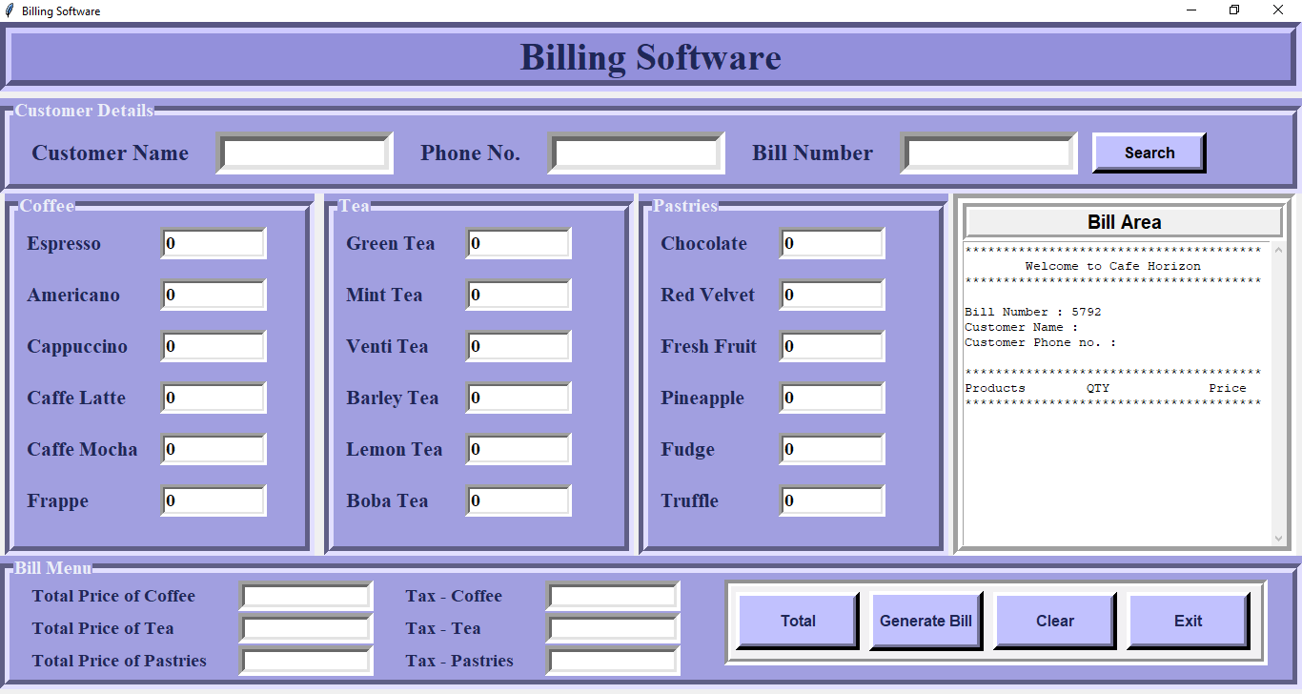

Empty customer information validation (on clicking Generate Bill Button) –

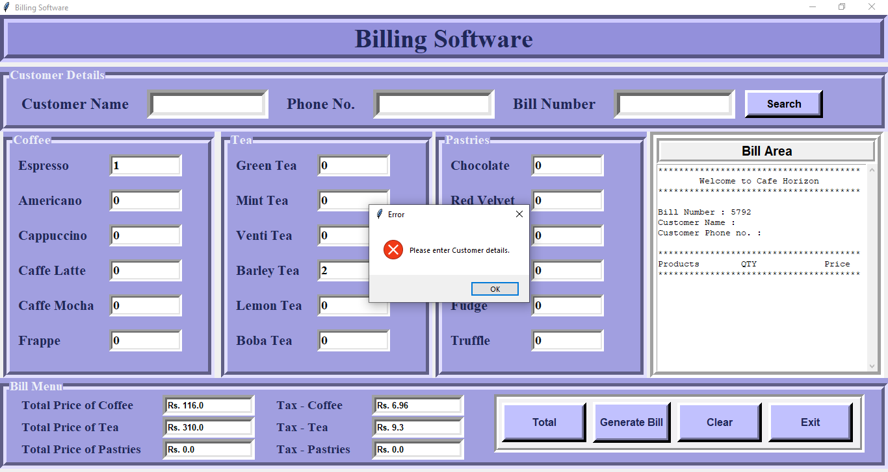

Customer name validation (on clicking Generate Bill Button) –

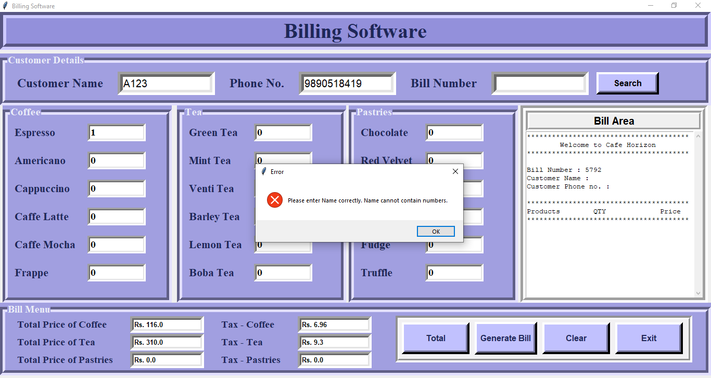

Customer phone number validation (on clicking Generate Bill Button) –

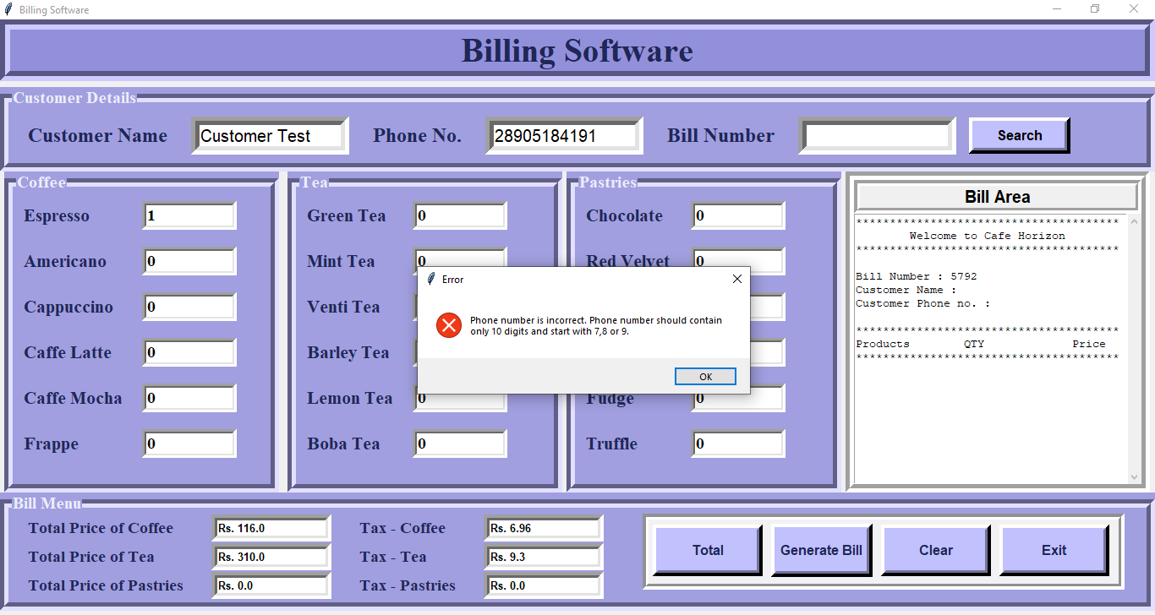

Validation on Bill (on clicking Generate Bill Button) -

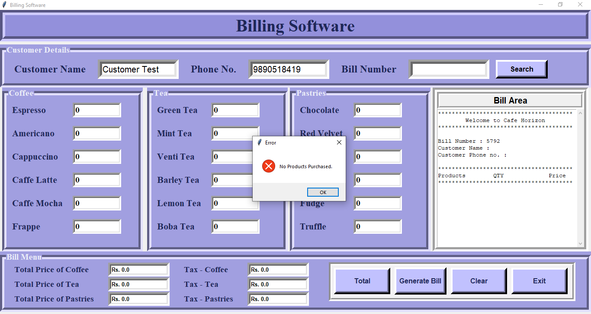

Clicking on Total button –

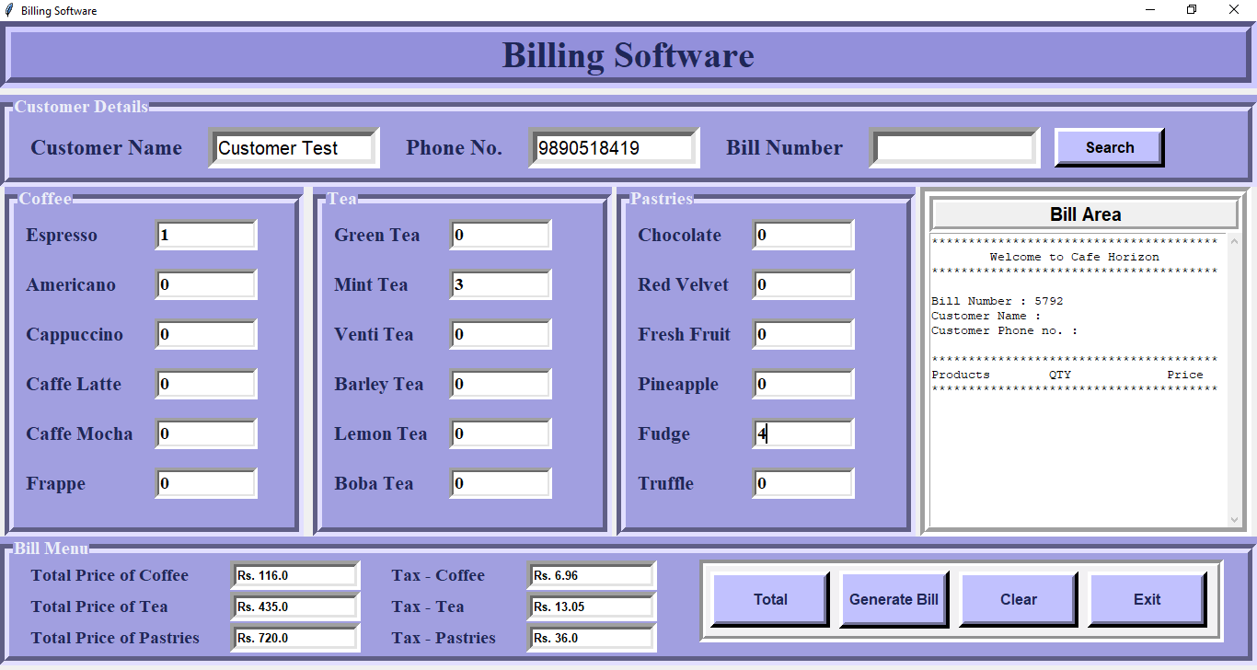

Clicking on Generate Bill button (when all information are valid) –

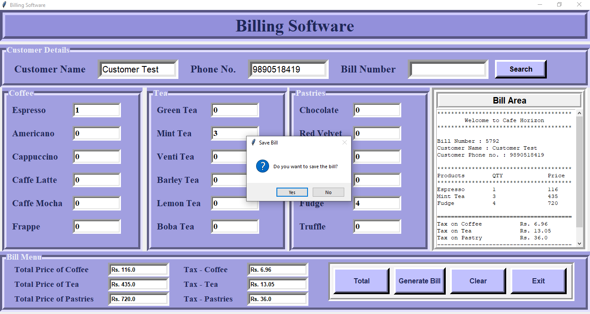

After Saving Bill –

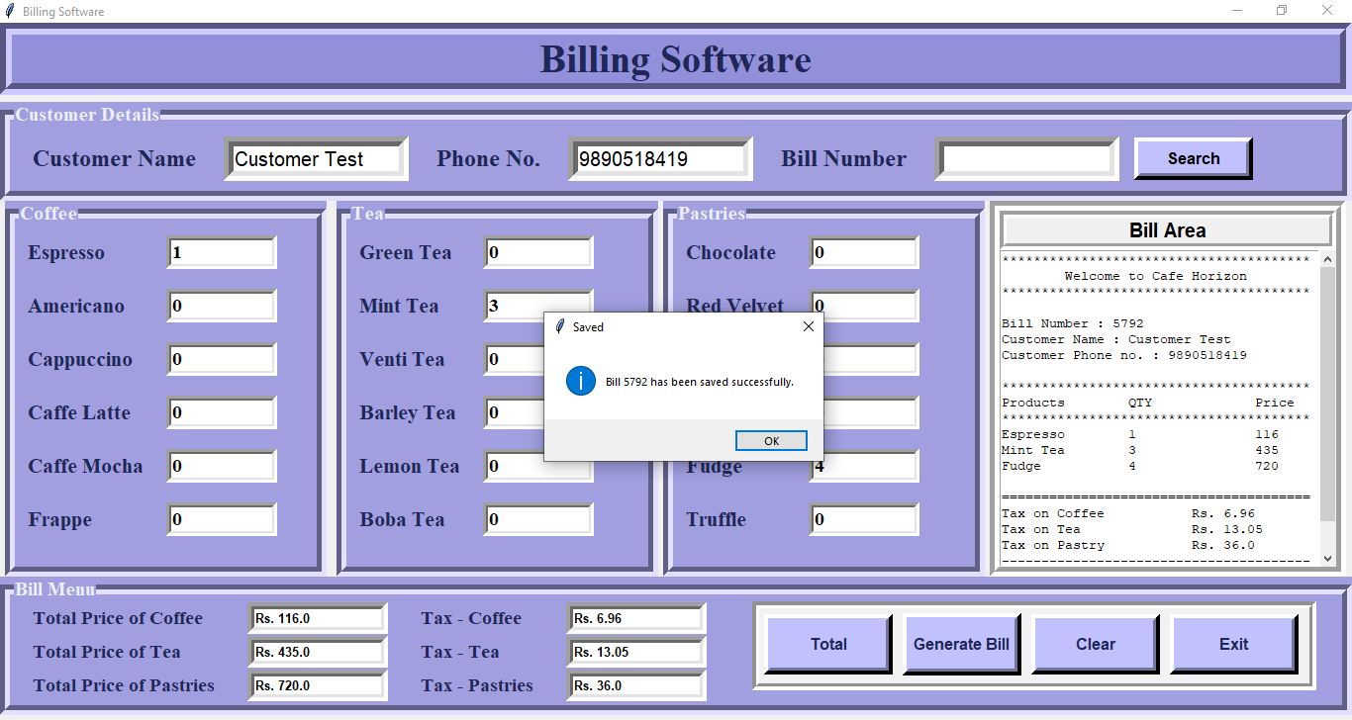

Clicking on Clear button –

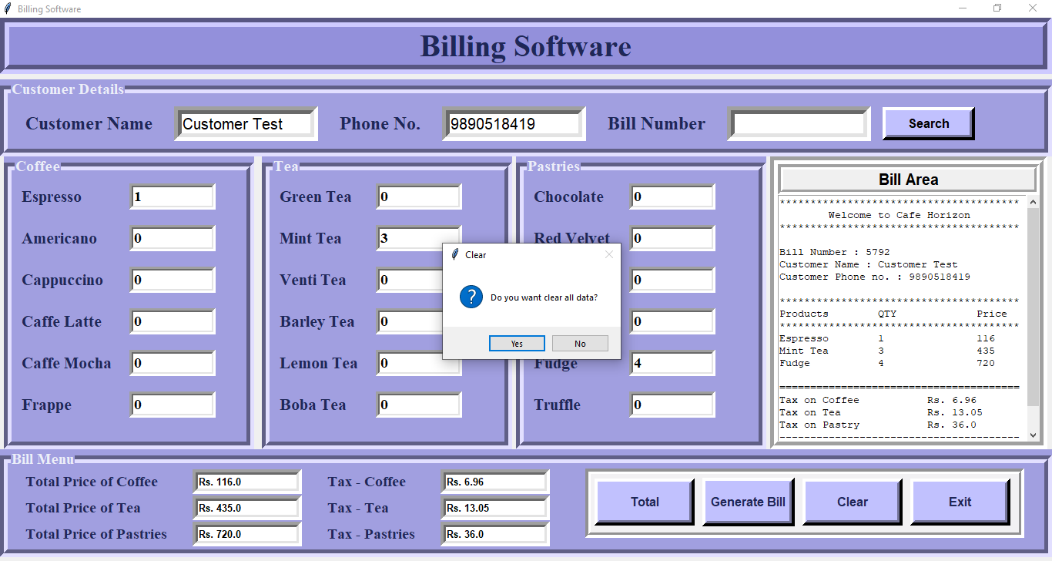

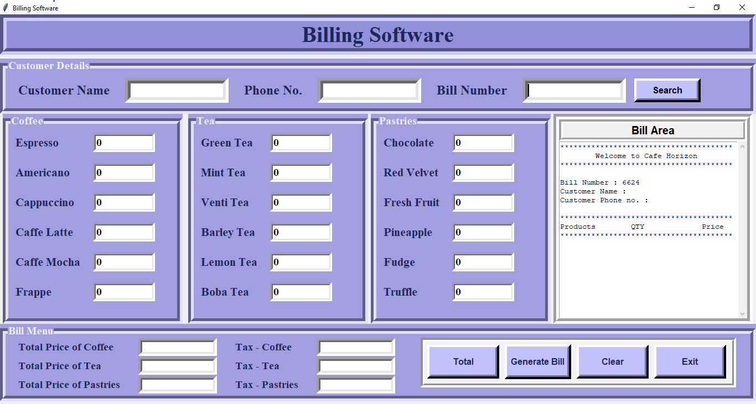

Searching a Bill –

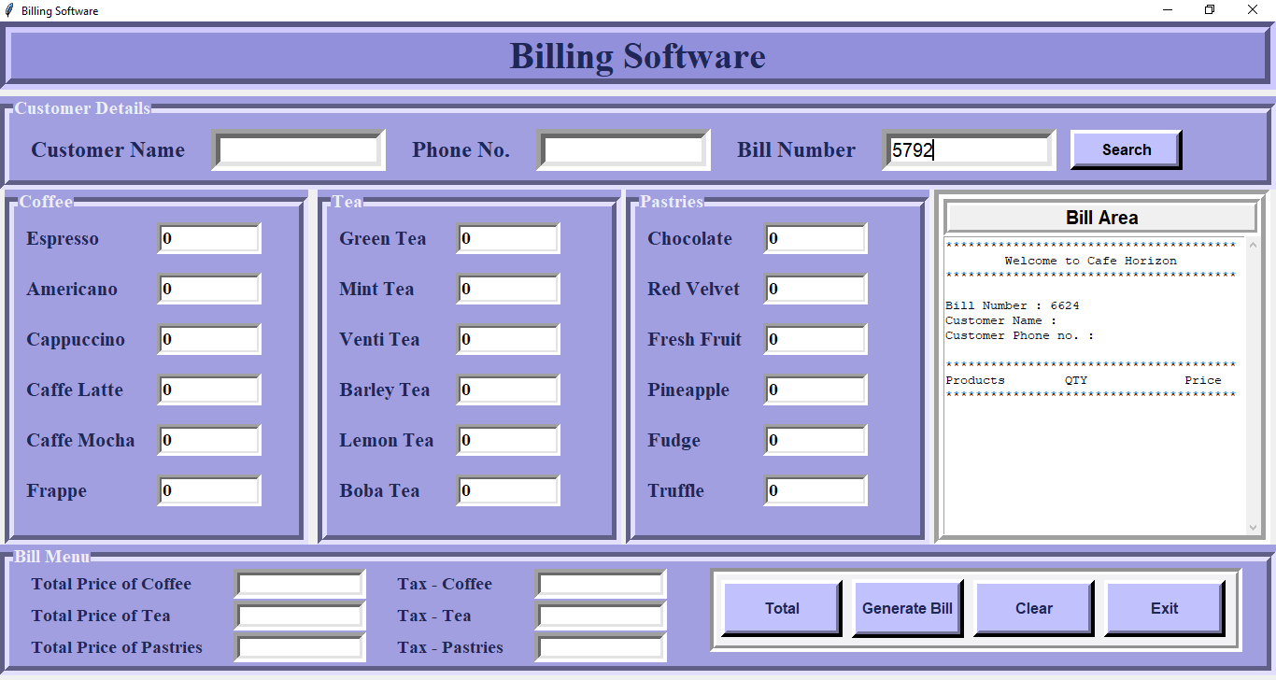

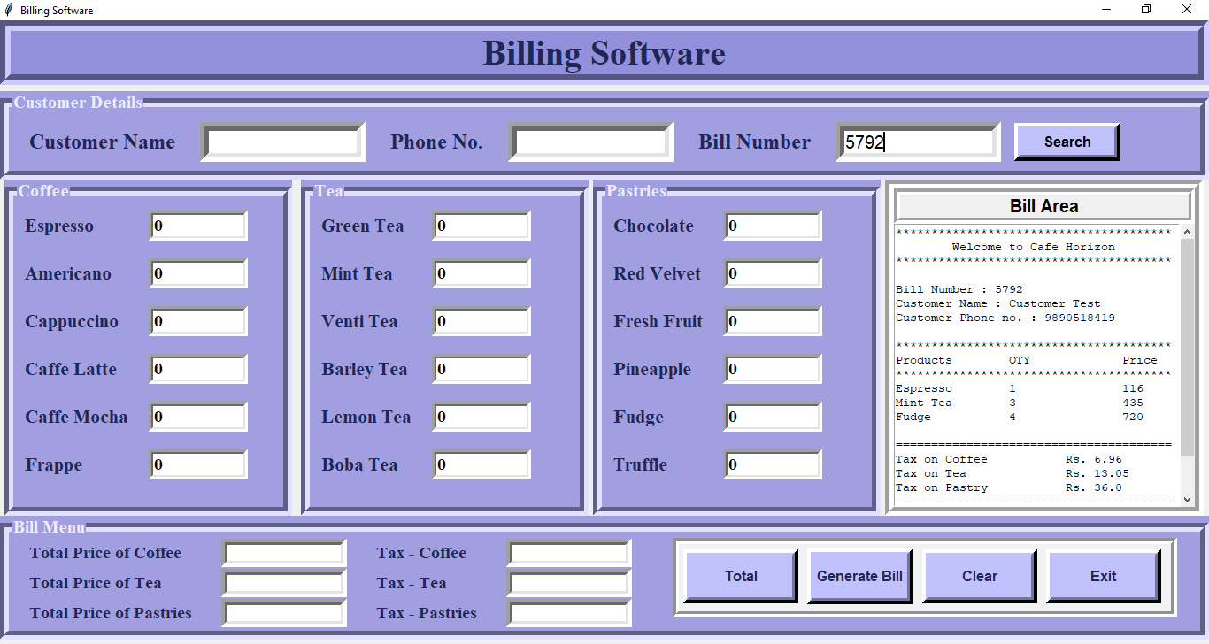

Clicking on Exit button –

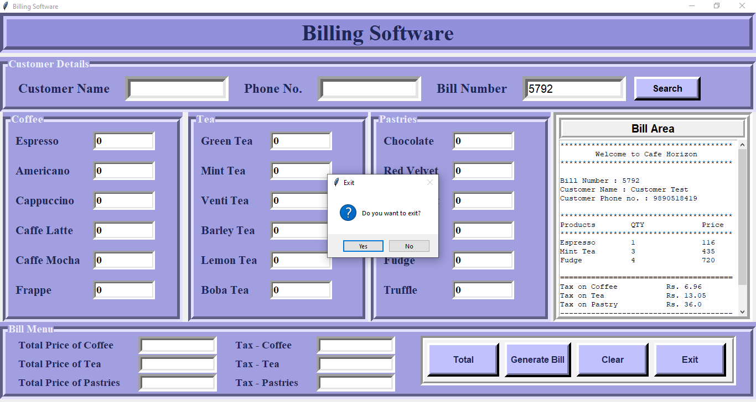

## 5. Code Snippet:

Libraries imported/used –

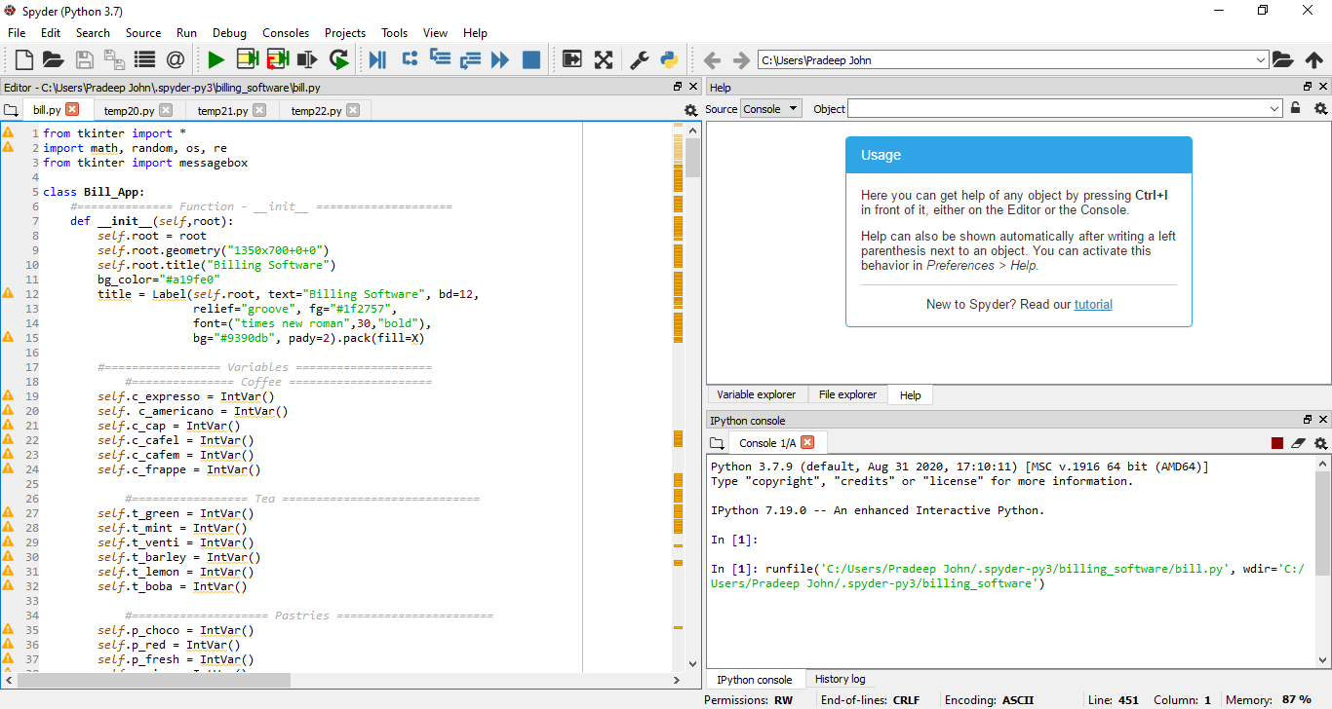

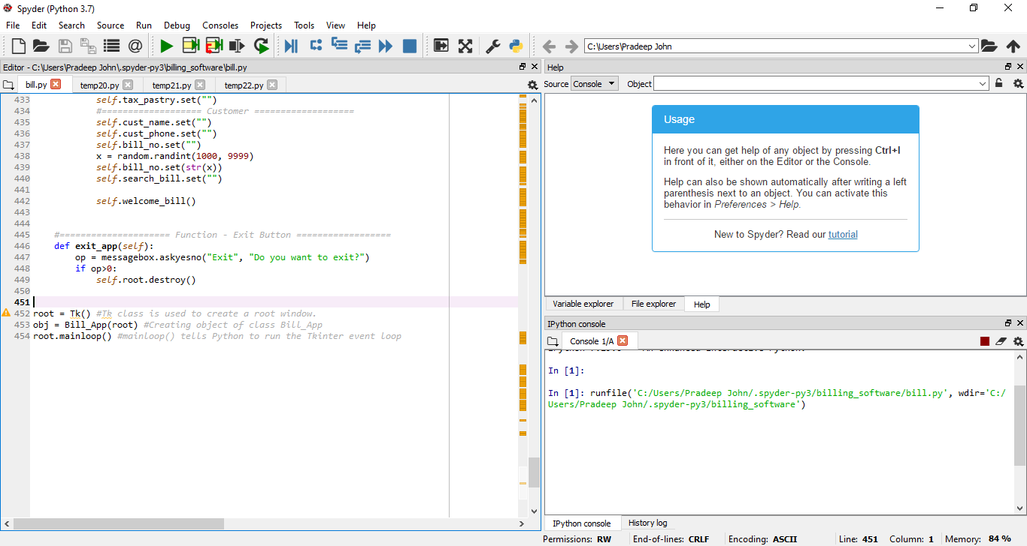

Function for Total button –

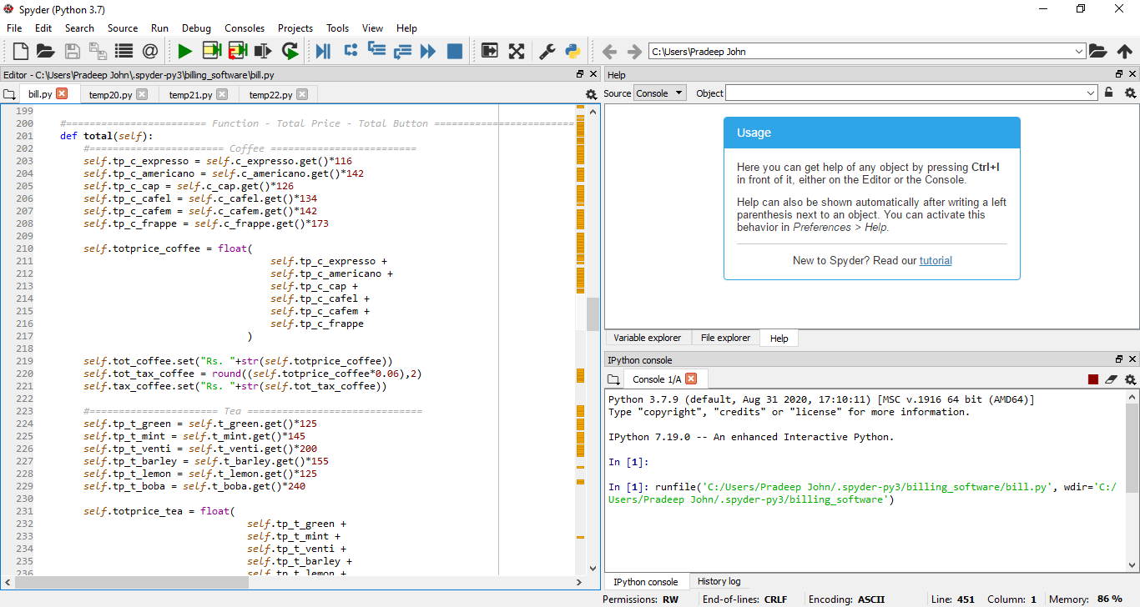

Function for Bill Area/ Generate Bill Button –

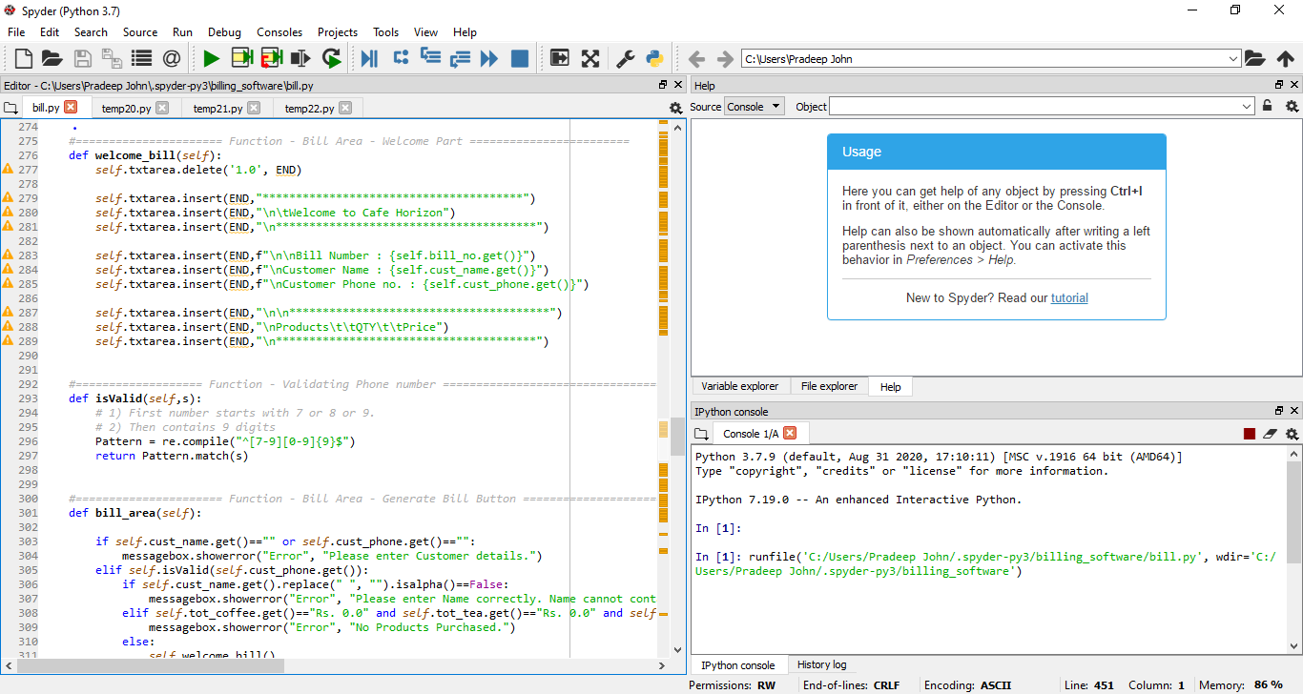

Function for Save Bill and Search Bill –

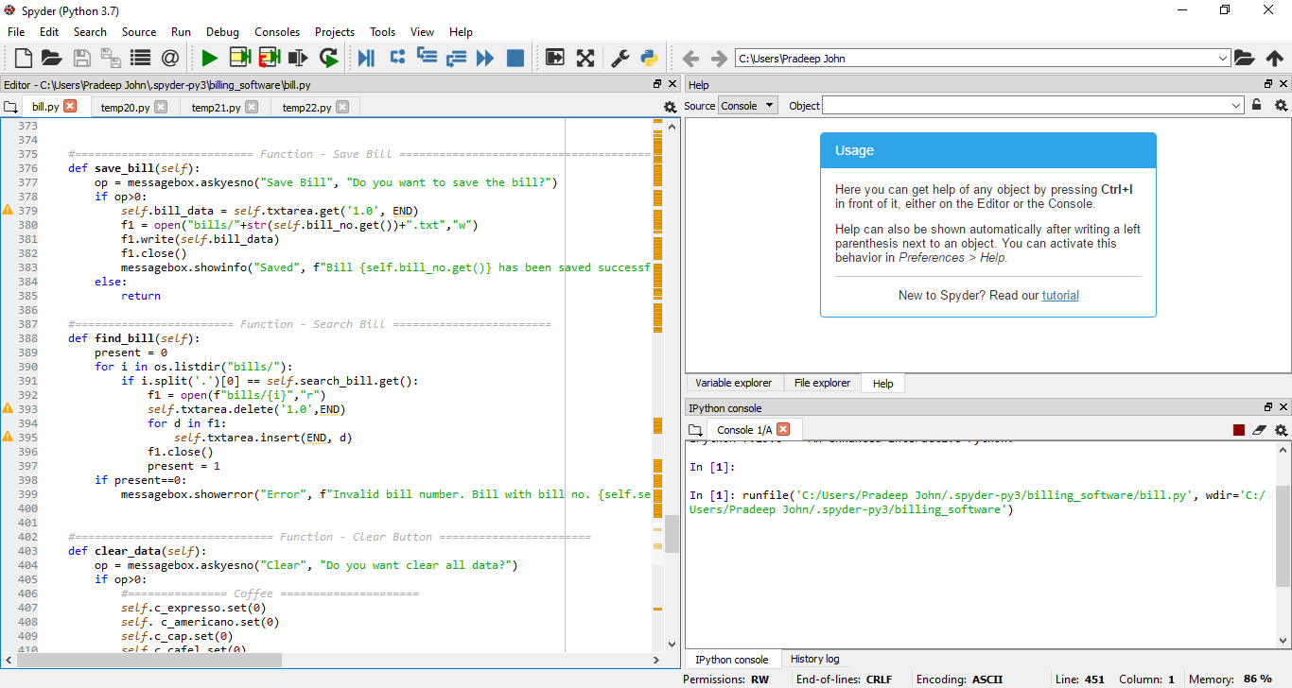

Function for Clear button –

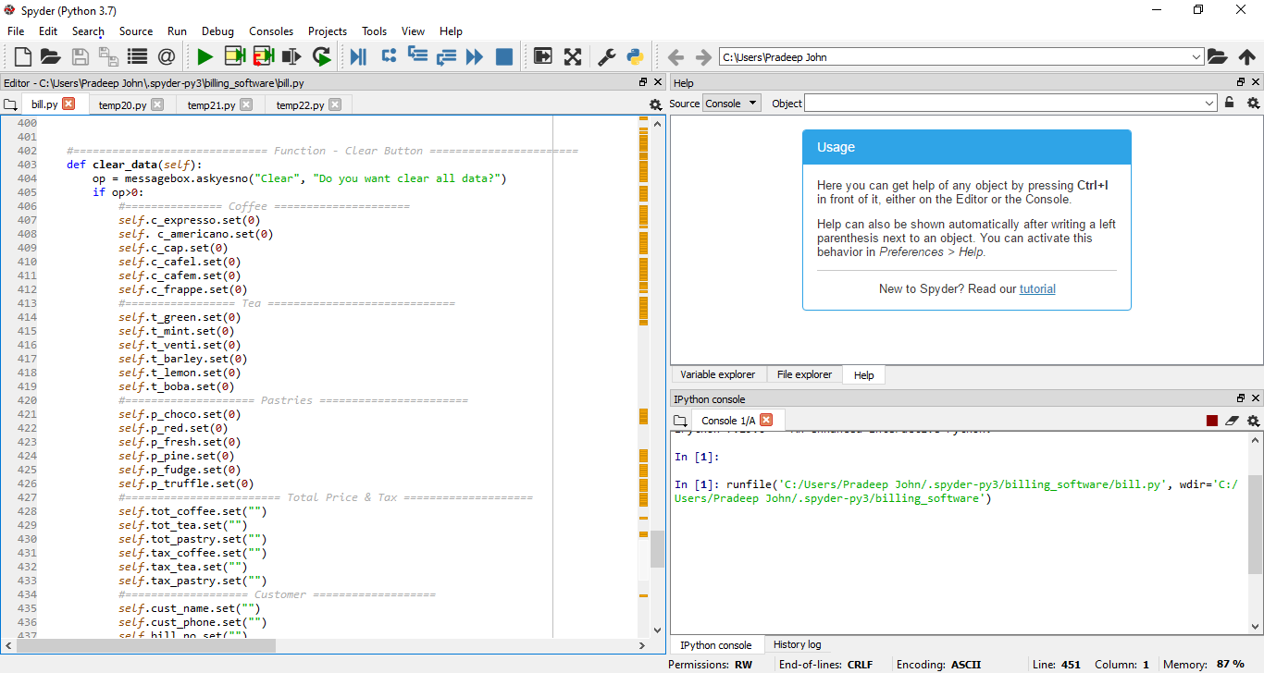

Function for Exit button –

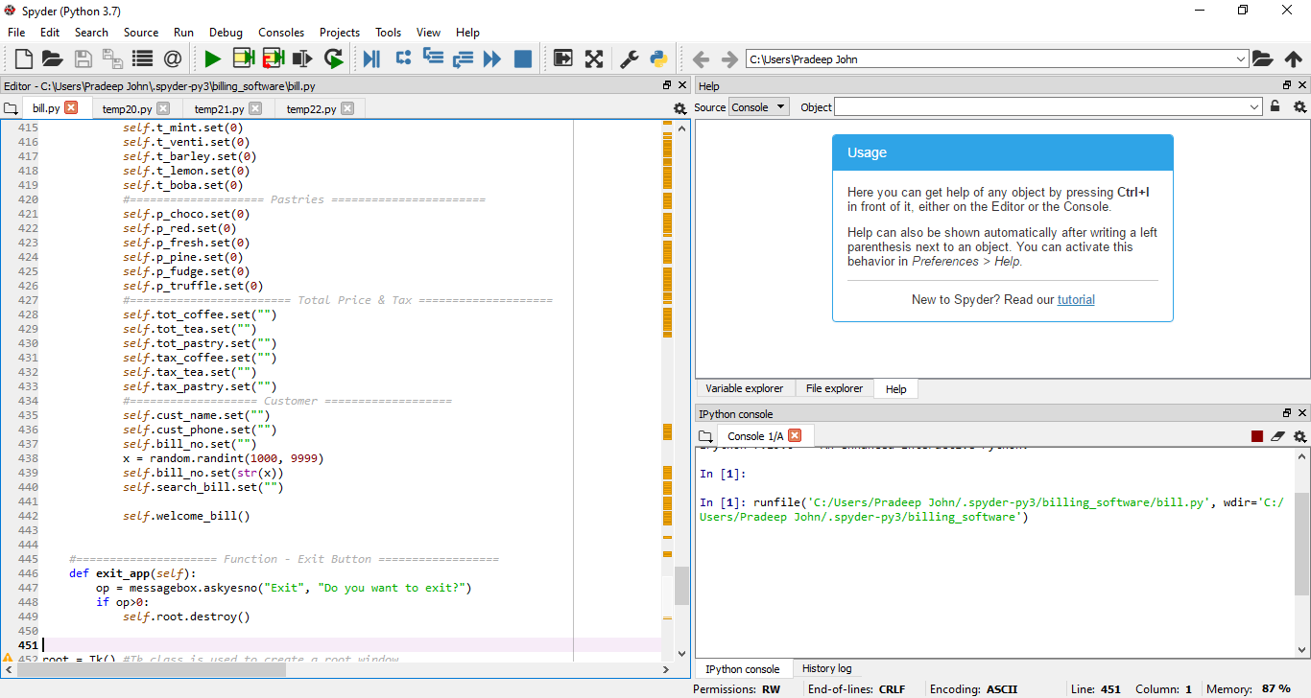

## 6. References:

<https://tallysolutions.com/erp-software/billing-software-its-benefits/>